1257535_Expose_Seminararbeit_Digitale_Geschaeftsmodelle_commented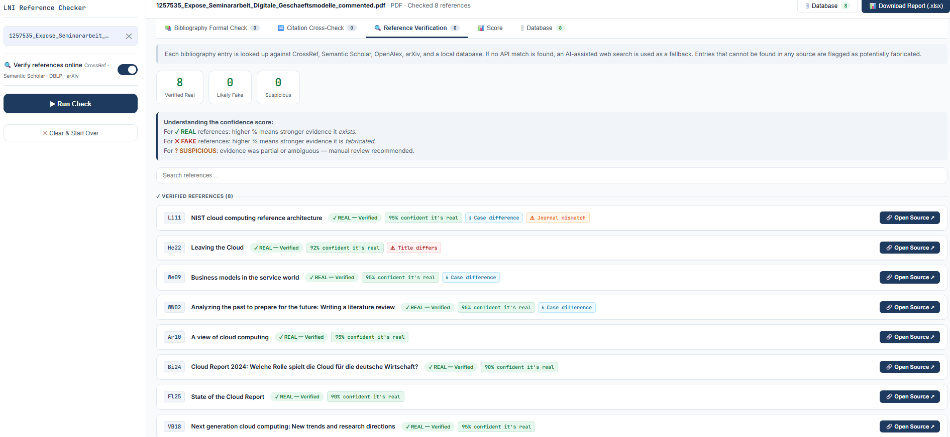lni_full_test (1)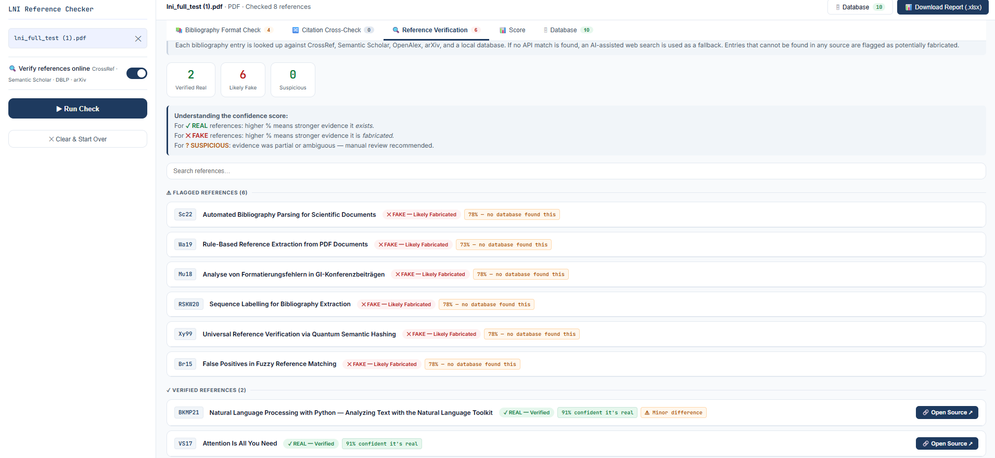
Test (1)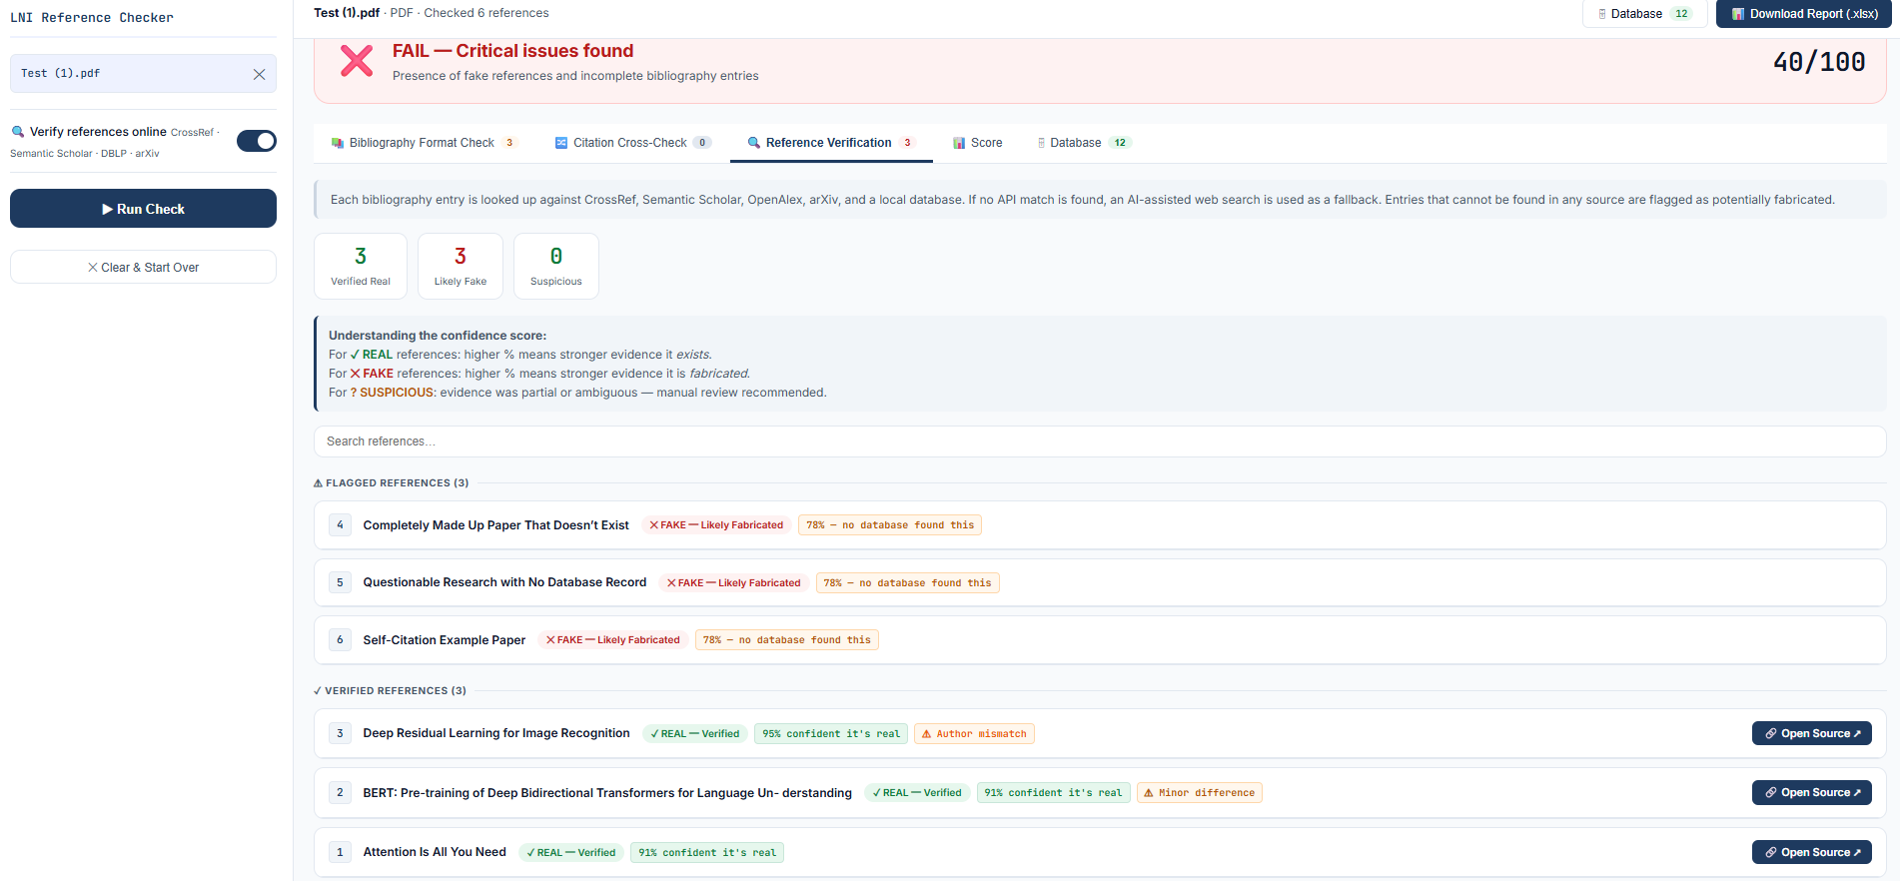
LNI-Autorenrichtlinien
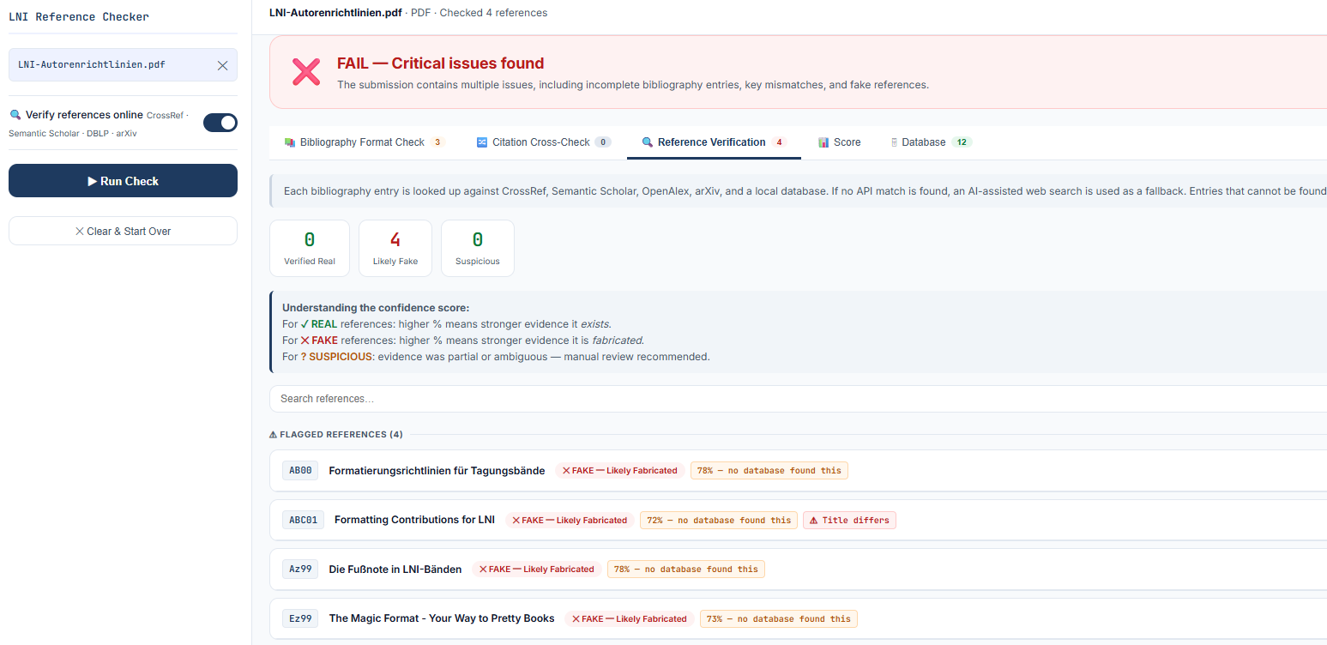lni-paper-example-de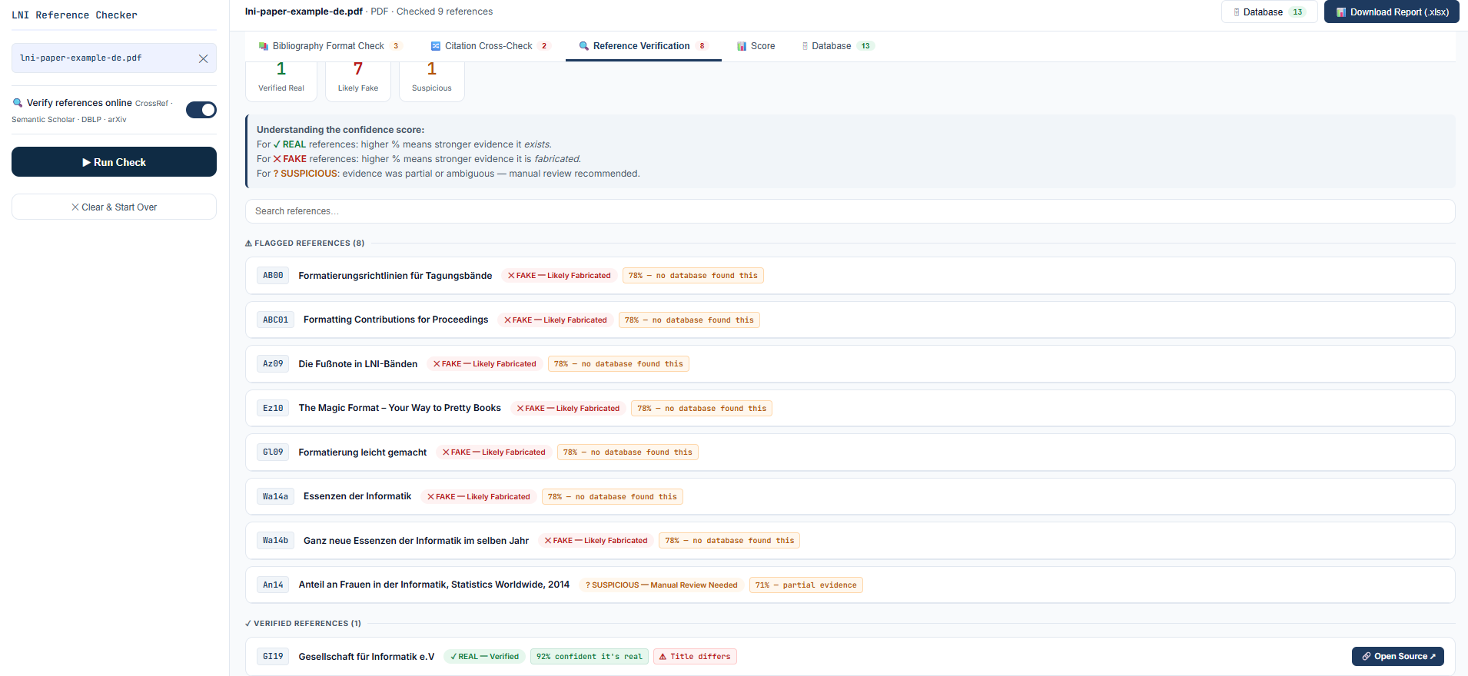2602.05930v1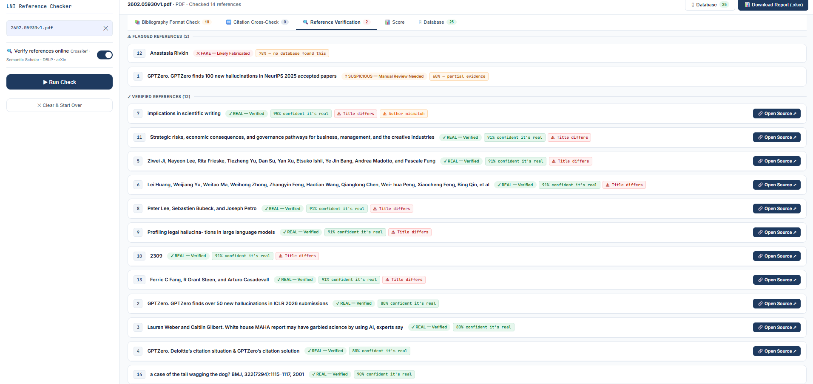
proceedings-example 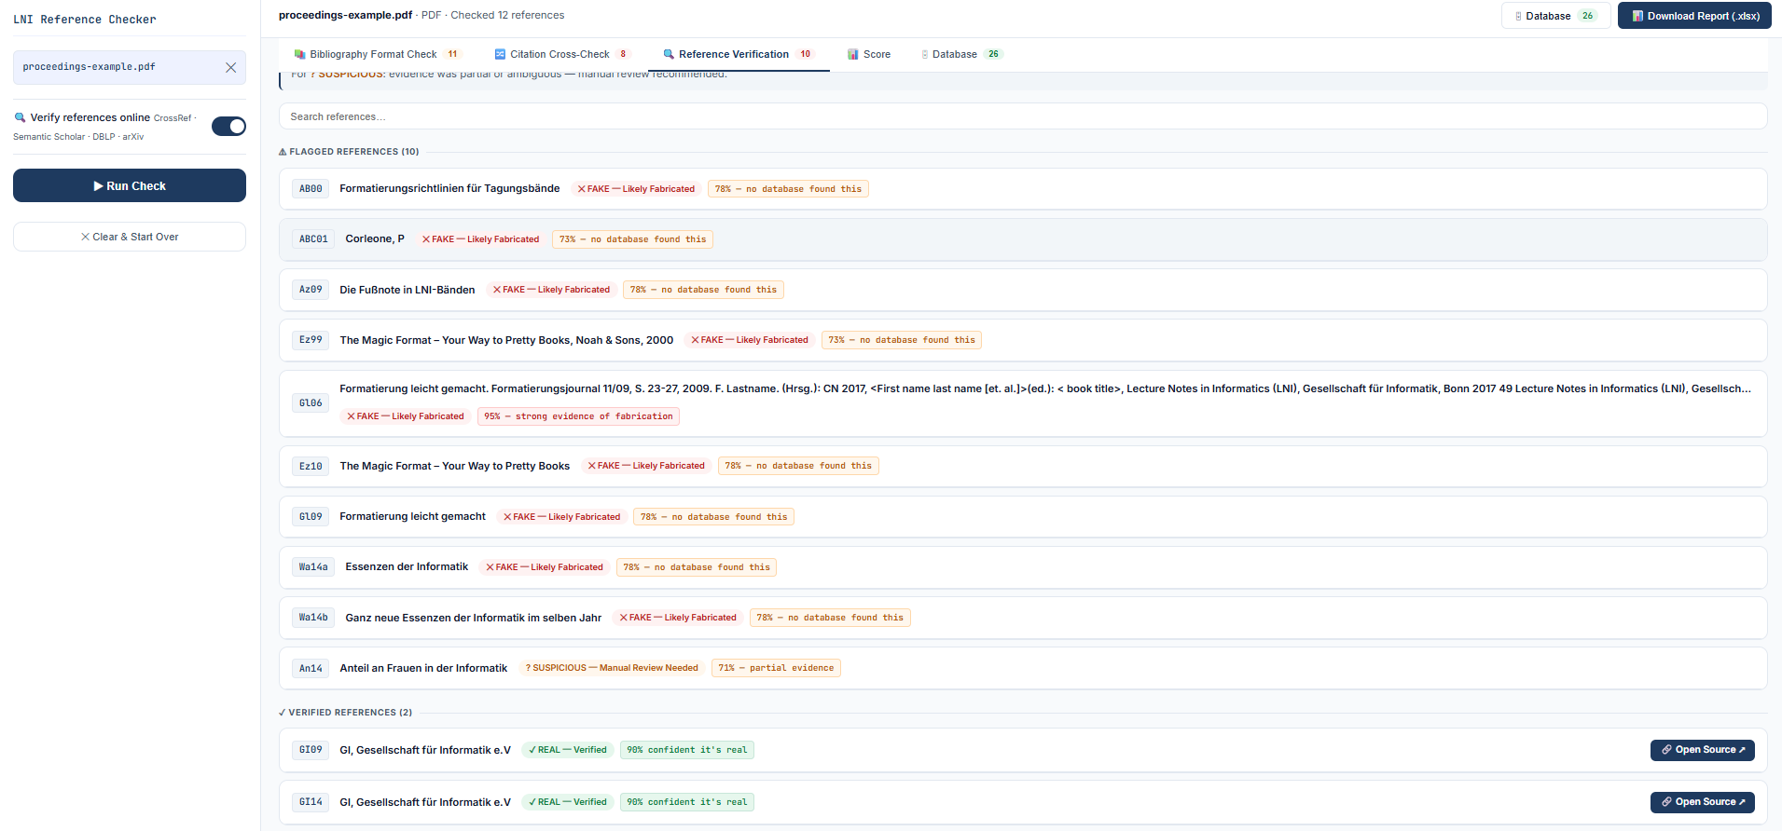
01_perfect_entry.pdf 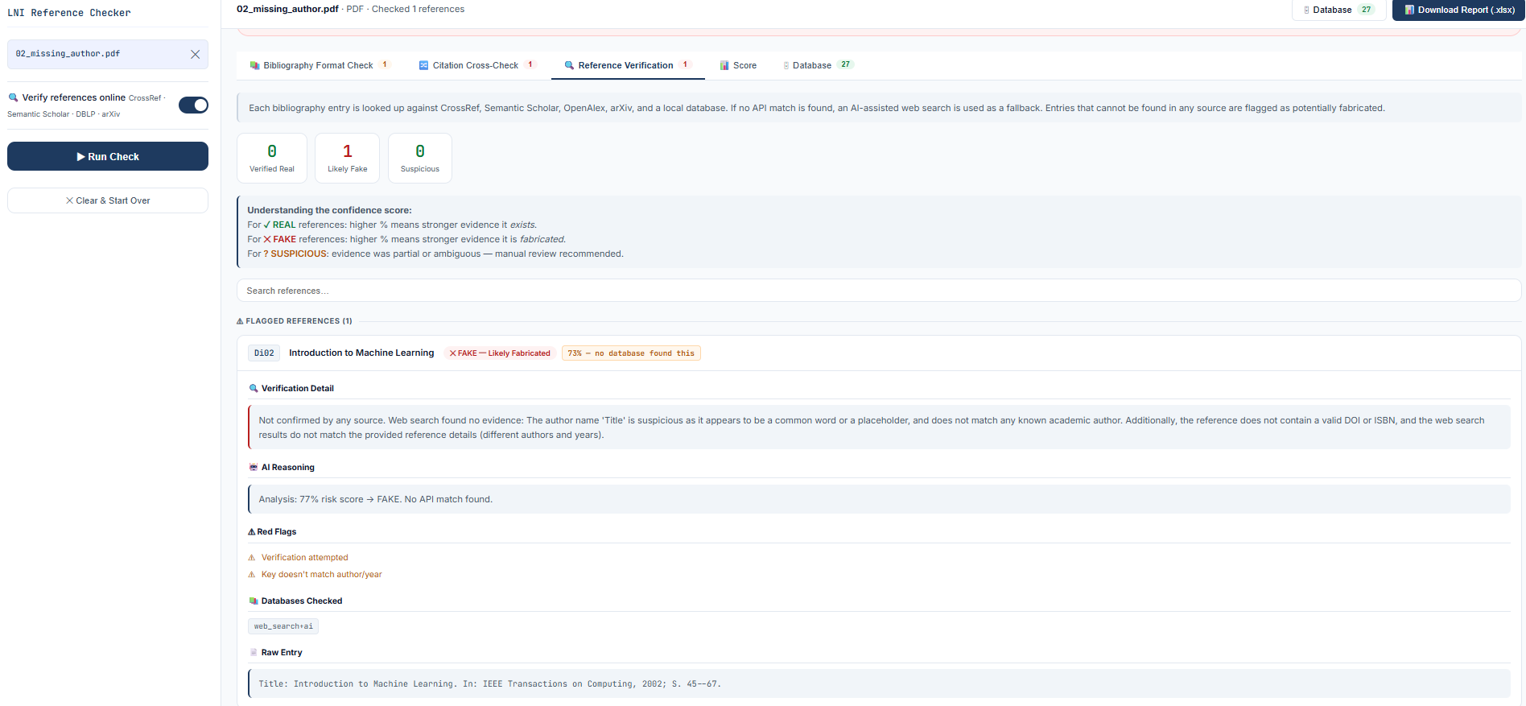
02_missing_author.pdf
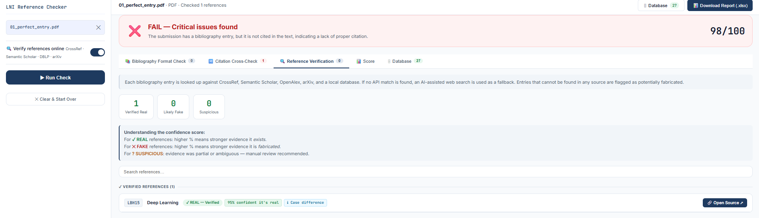
03_missing_journal.pdf
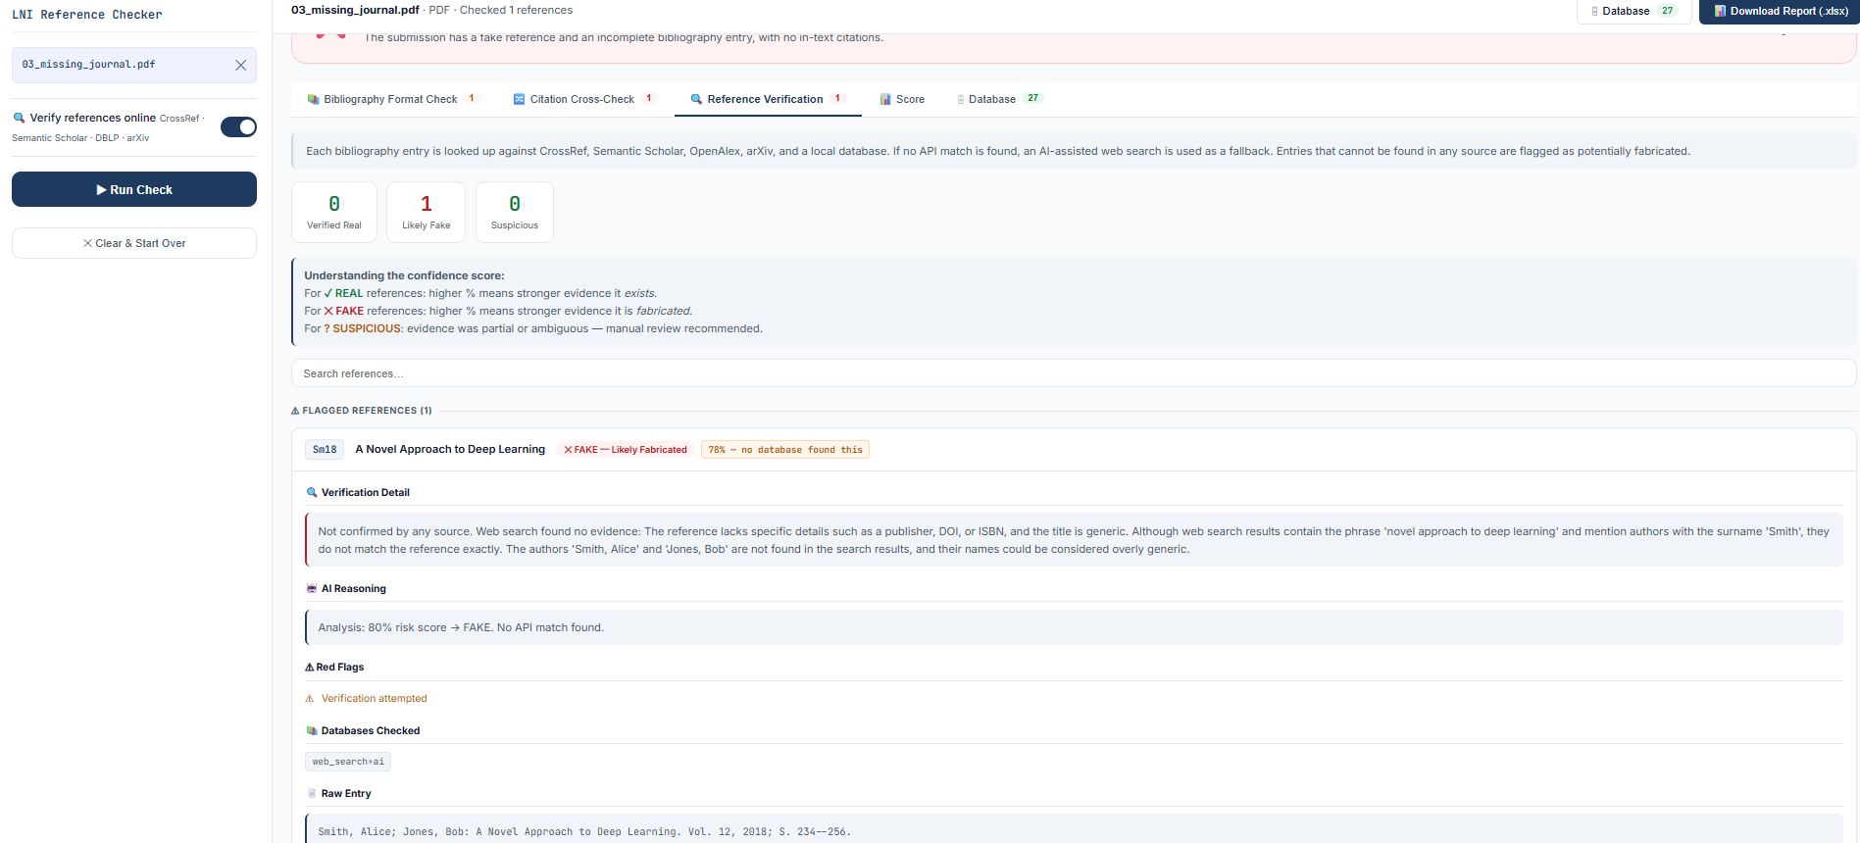
04_wrong_author_format.pdf
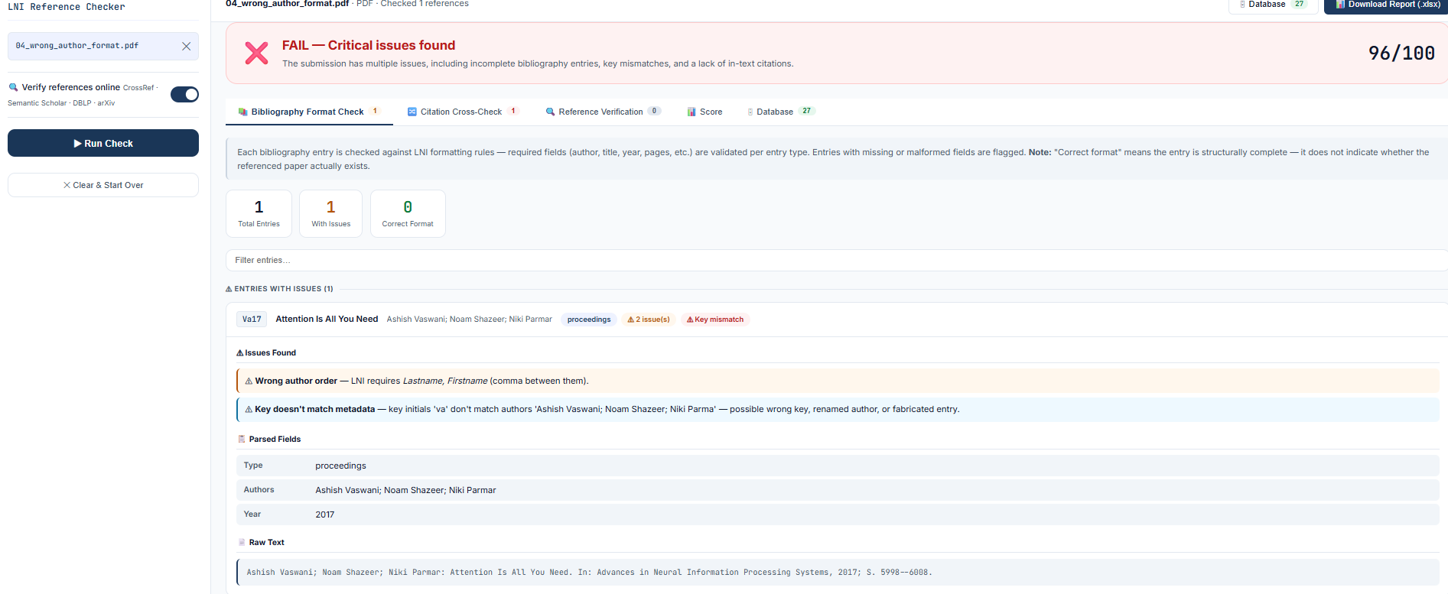 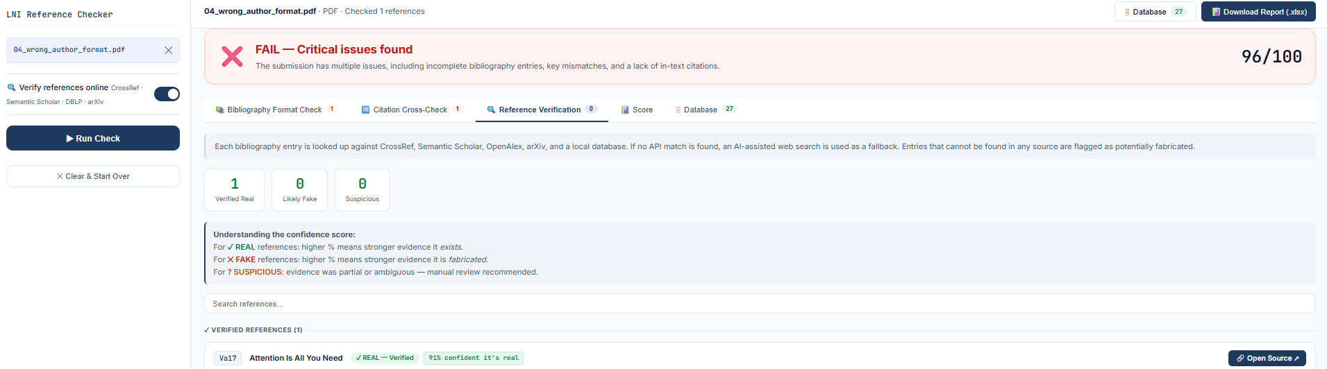05_invalid_key.pdf
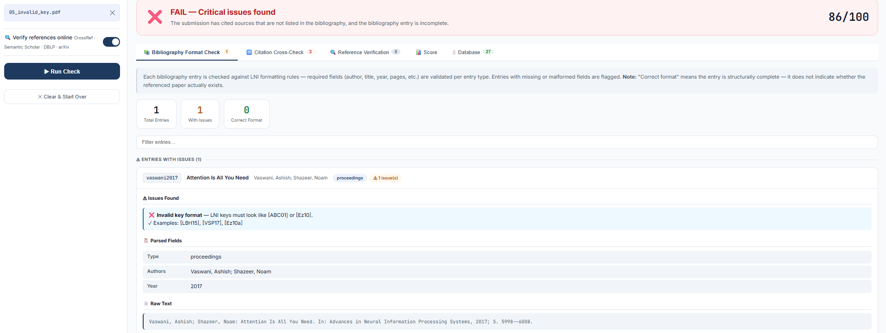
06_year_mismatch.pdf 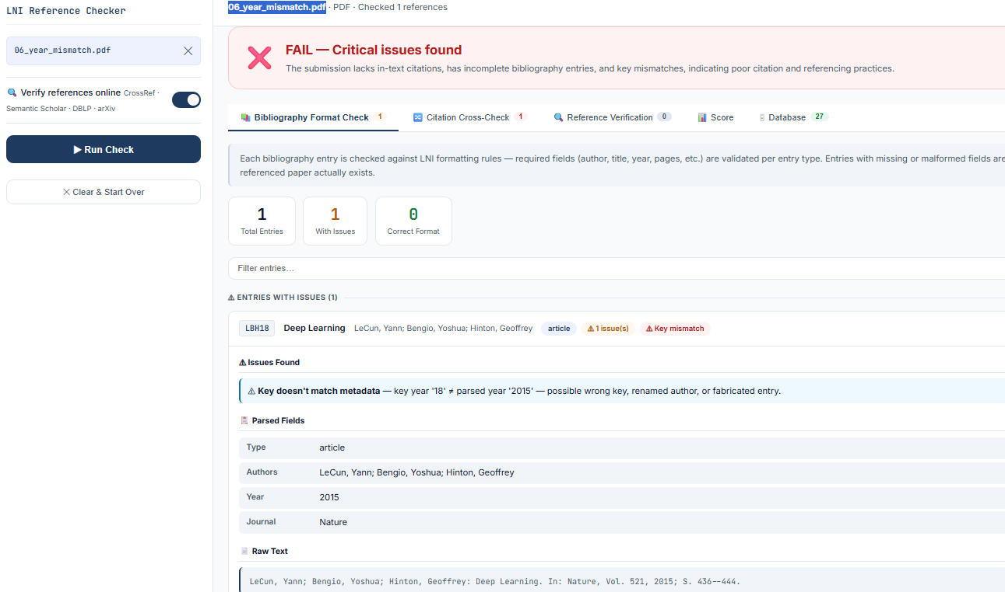
07_wrong_dash_format.pdf ·
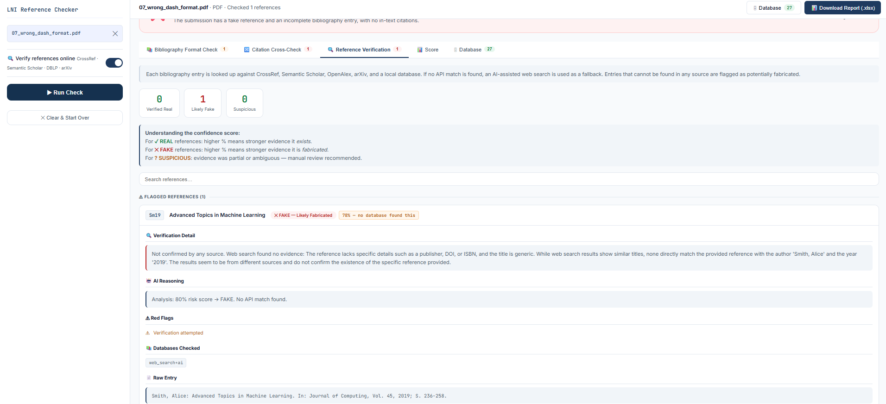
08_website_entry.pdf ·
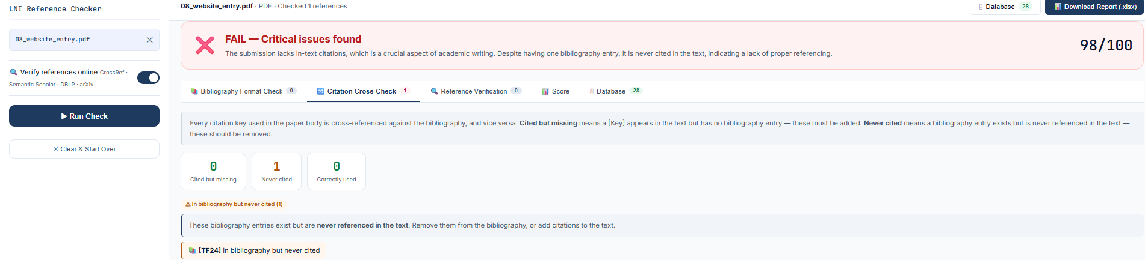
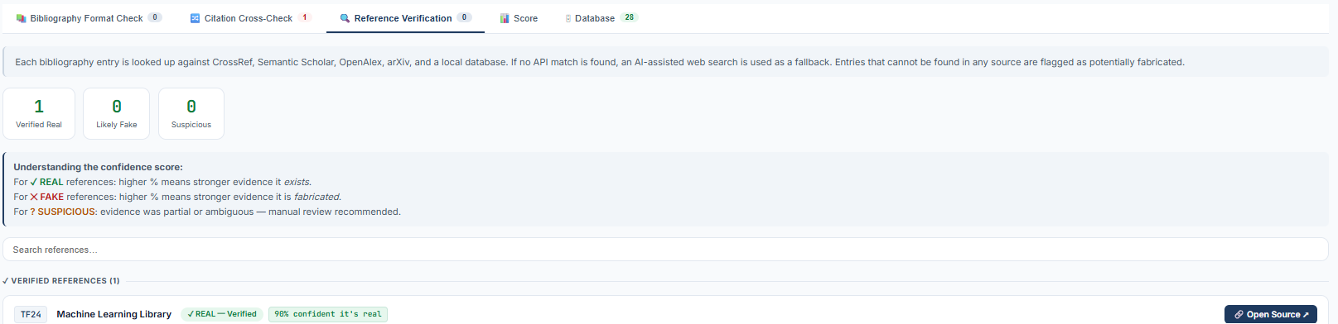 09_book_entry.pdf 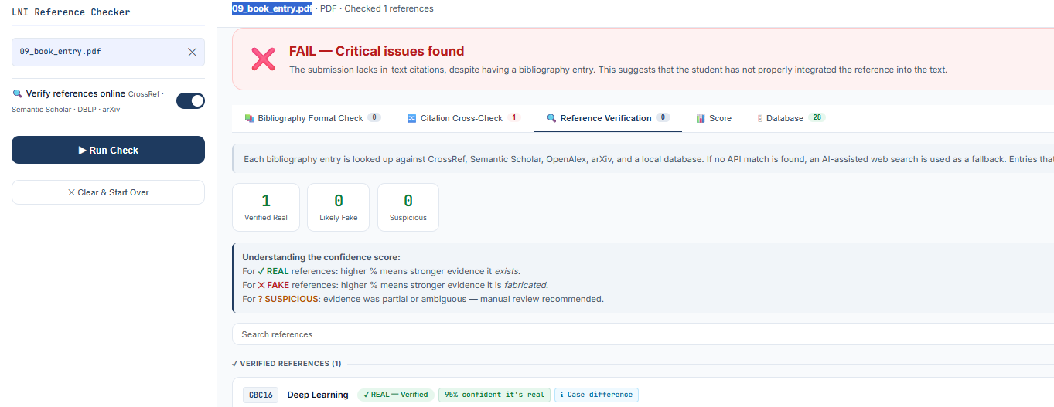 10_proceedings_entry.pdf 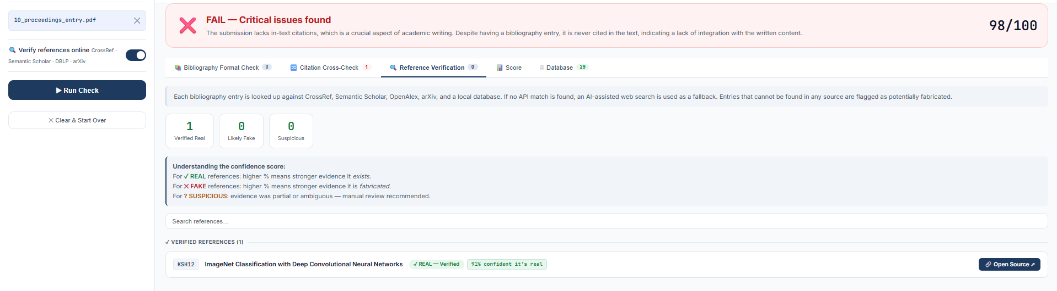 11_missing_title.pdf 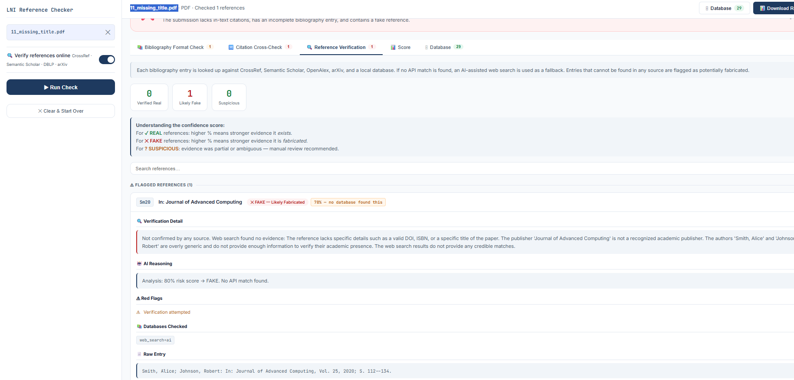
12_missing_year.pdf 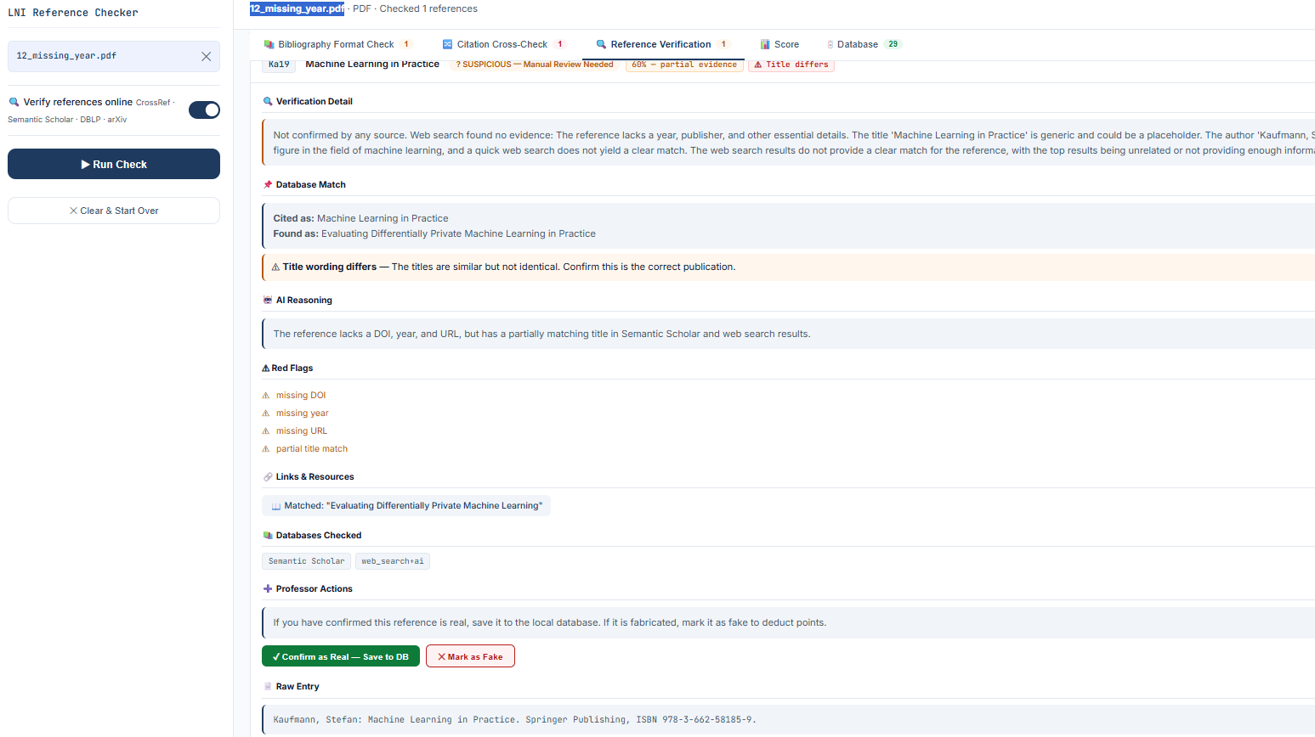
13_future_year.pdf 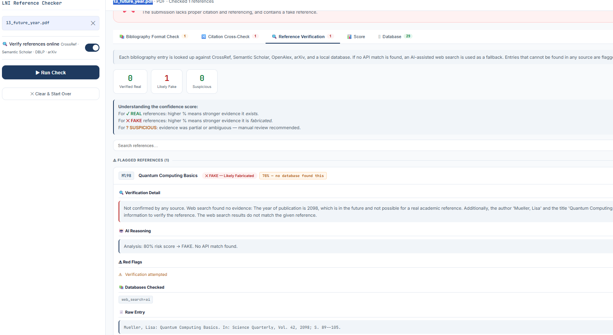
14_high_page_span.pdf
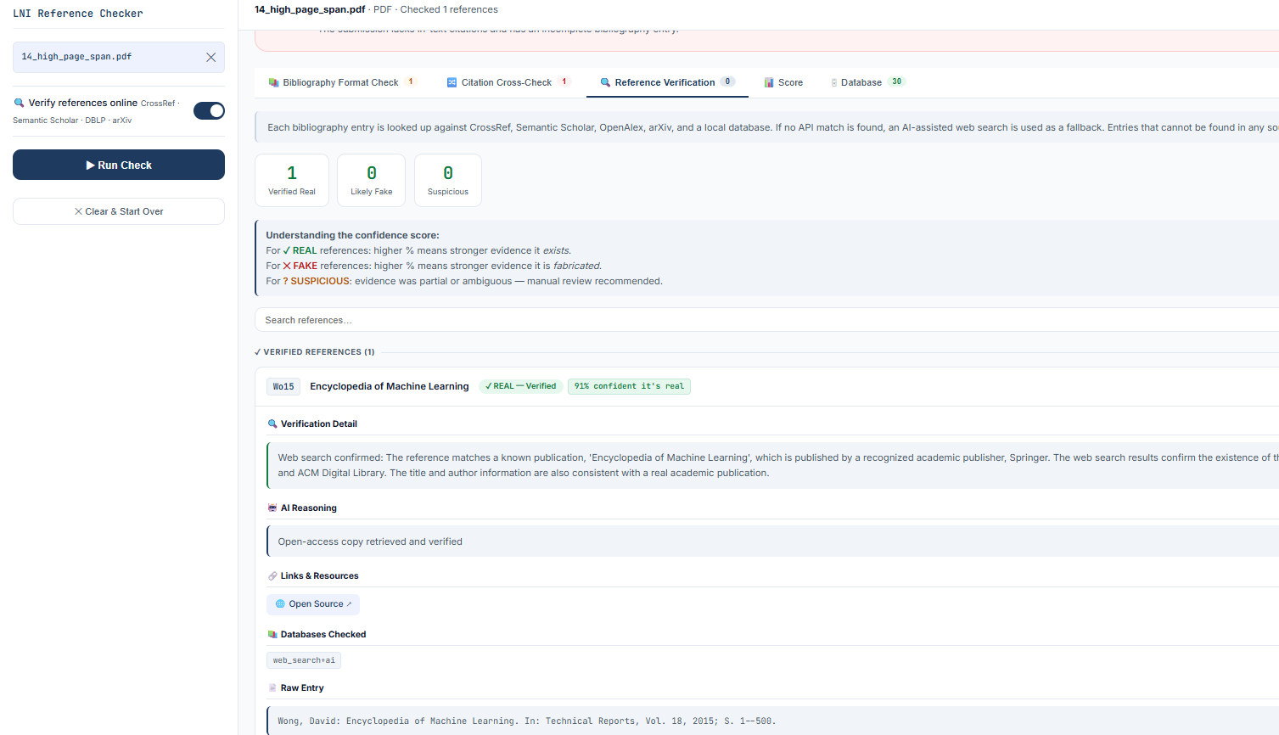 15_single_author.pdf 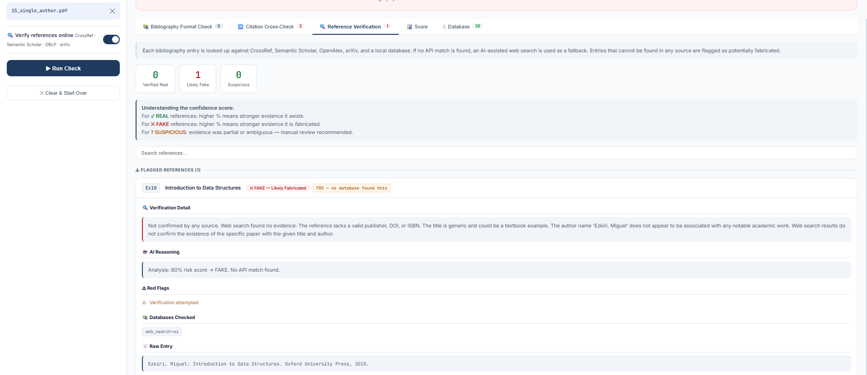 16_four_authors.pdf 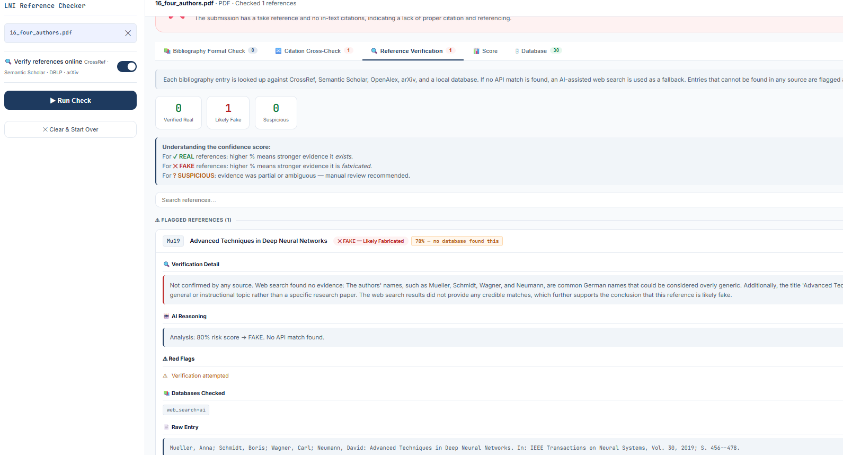
17_hyphenated_name.pdf 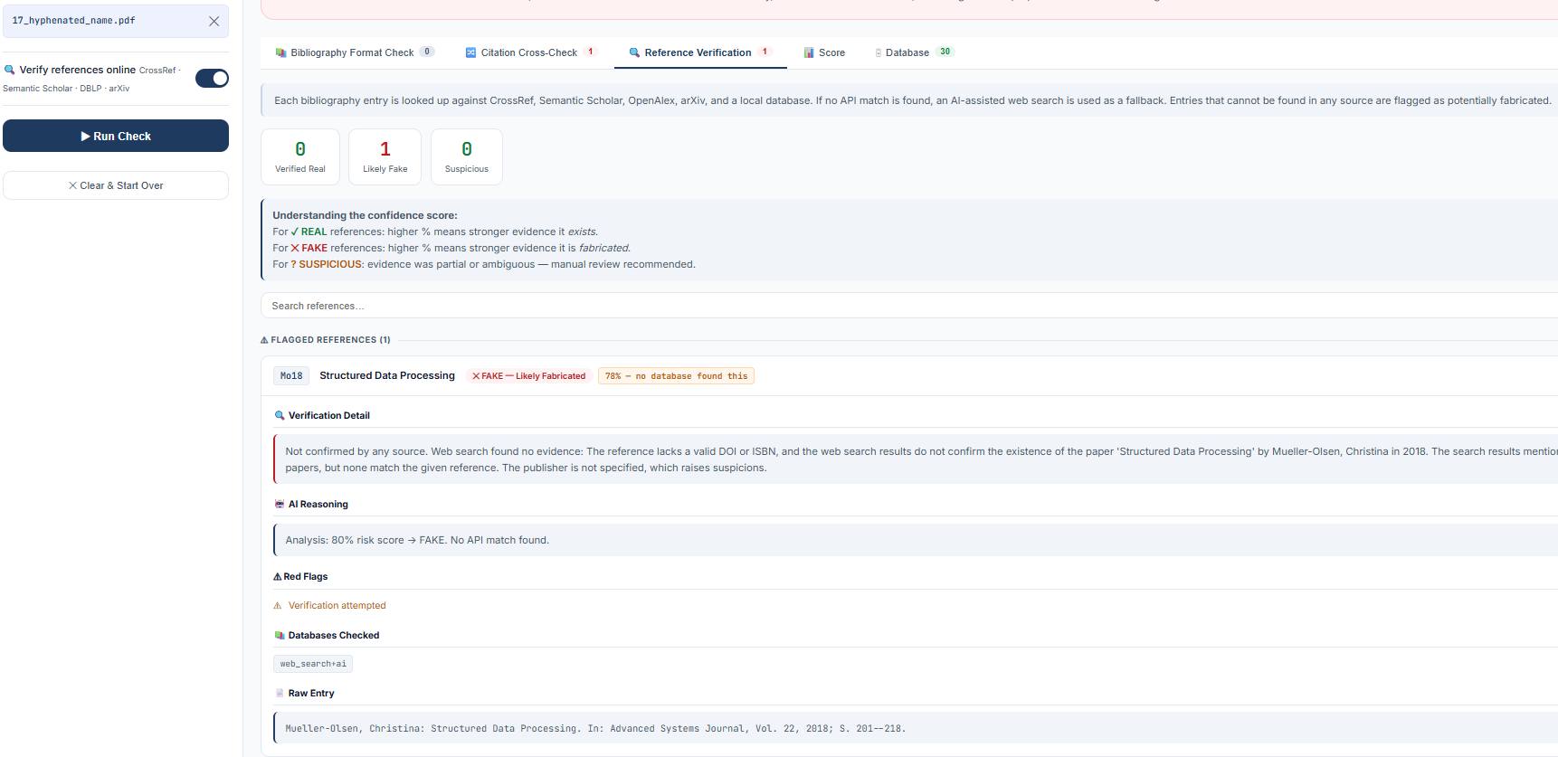
18_german_umlauts.pdf 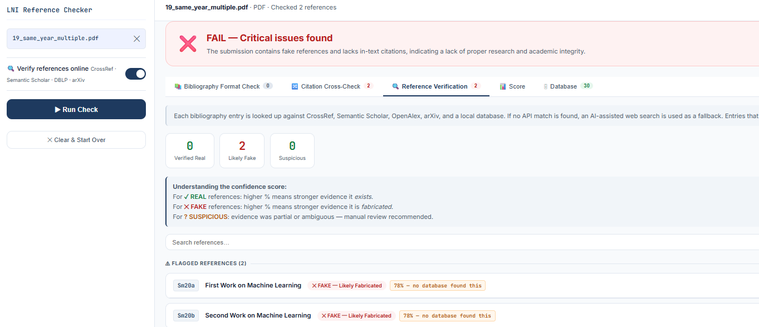
19_same_year_multiple.pdf 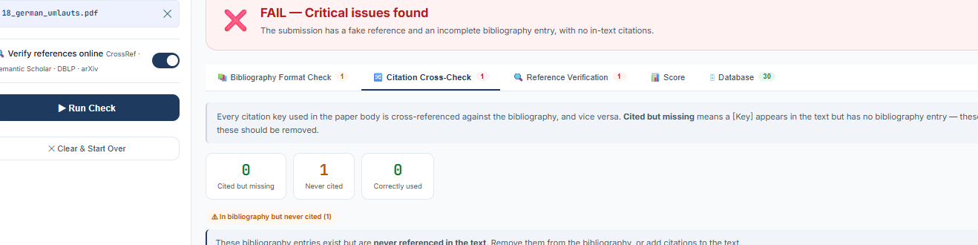 20_misc_entry.pdf
